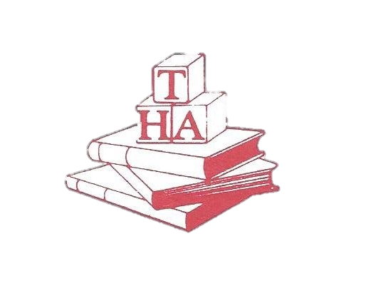
THE HAYNES ACADEMY
LARGO PARK EARLY LEARNING CENTER
(301) 341-5437
2016-2017 HOLIDAY/SCHOOL CLOSINGS

Labor Day September 5, 2016

Veterans Day November 11, 2016

Thanksgiving November 24-25, 2016

Christmas Eve

Christmas December 26, 2016

New Year’s Eve

New Year’s Holiday January 2, 2017

Dr. M. L. King, Jr. Day January 16, 2017

President’s Day February 20, 2017

Good Friday April 14, 2017

Memorial Day May 29, 2017

Independence Day July 4, 2017

Staff Development Day(s) August 11, 2017

SNOW/INCLEMENT WEATHER POLICY

THE CHILD CARE CENTERS WILL CLOSE IF THE FEDERAL GOVERNMENT CLOSES. WE FOLLOW THE HAYNES ACADEMY DELAYED OPENING POLICY. IN CASE OF INCLEMENT WEATHER, PLEASE CHECK YOUR E-MAIL, CALL THE SCHOOL OR TUNE IN TO YOUR LOCAL TELEVISION STATIONS FOR FURTHER INSTRUCTIONS. IF SEVERE WEATHER DEVELOPS DURING THE DAY, PLEASE PICK UP YOUR CHILD(REN) EARLY.

